Jerusalem Lodge, No. 100, F. & A. M.
(Tampa Times, January 28, 1915)
Jerusalem Lodge, No. 100, was organized in 1910 and at present has a membership of twenty‑five. This lodge is composed of a number of men who are engaged in active business in Tampa, among whom are D. J. Reid, the Master, who is a tailor; Z. D. Walker, painter and contractor; L. R. Thomas, of the Afro‑American Insurance Company, and the Secretary, Peter Johnson, who is president of the Florida Industrial and Commercial Company, undertakers at 1120 Central Avenue.
Peter Johnson is a 32d degree Mason. In 1911 he was elected as the Royal Grand Patron of the state of Florida. He was in the service of the government for sixteen years. Johnson was born in Gainesville, Fla., in 1866, came to Tampa in 1889, joined Jerusalem Lodge in 1890, was one of its charter members, and after working his way through the chairs he was elected master of the lodge, which he held for ten years. He is also Commander in Chief of the Consistory.
The officers are: Worshipful Master, D. J. Reid; Senior Warden, Z. D. Walker; Junior Warden, John Mitchell; Senior Deacon, W. Williams; Treasurer, L. R. Thomas; Secretary, Peter Johnson, Junior Deacon Fred Bryant, Tiler E. Buggs, and Chaplain Lee Rutherford.
This lodge is a very successful one and is showing wonderful progress. They meet on the first and third Thursdays of each month at the Masonic Hall, 612 Scott street.

Jerusalem Lodge No. 100, F. & A. M. (PHA)
Tampa, Florida
Historical Profile and 1915 Newspaper Record

Historical Introduction
Jerusalem Lodge No. 100, Free and Accepted Masons (Prince Hall Affiliated), stands as one of the foundational institutions of Tampa’s early African American community. Organized in 1910, the lodge quickly became a center of leadership, business development, and civic engagement for Black residents during the Jim Crow era. Its members included tailors, contractors, insurance executives, undertakers, and skilled tradesmen—men who shaped the economic and social life of Central Avenue and the surrounding neighborhoods.
The 1915 Tampa Times profile reproduced in this booklet is one of the earliest surviving public records of the lodge. It documents not only the officers and membership but also the professional accomplishments of its leaders, especially Peter Johnson, a 32nd‑degree Mason and one of Tampa’s most influential Black businessmen of the early 20th century.
This document preserves the original text while providing historical context and biographical sketches to support research, genealogy, and community history projects.
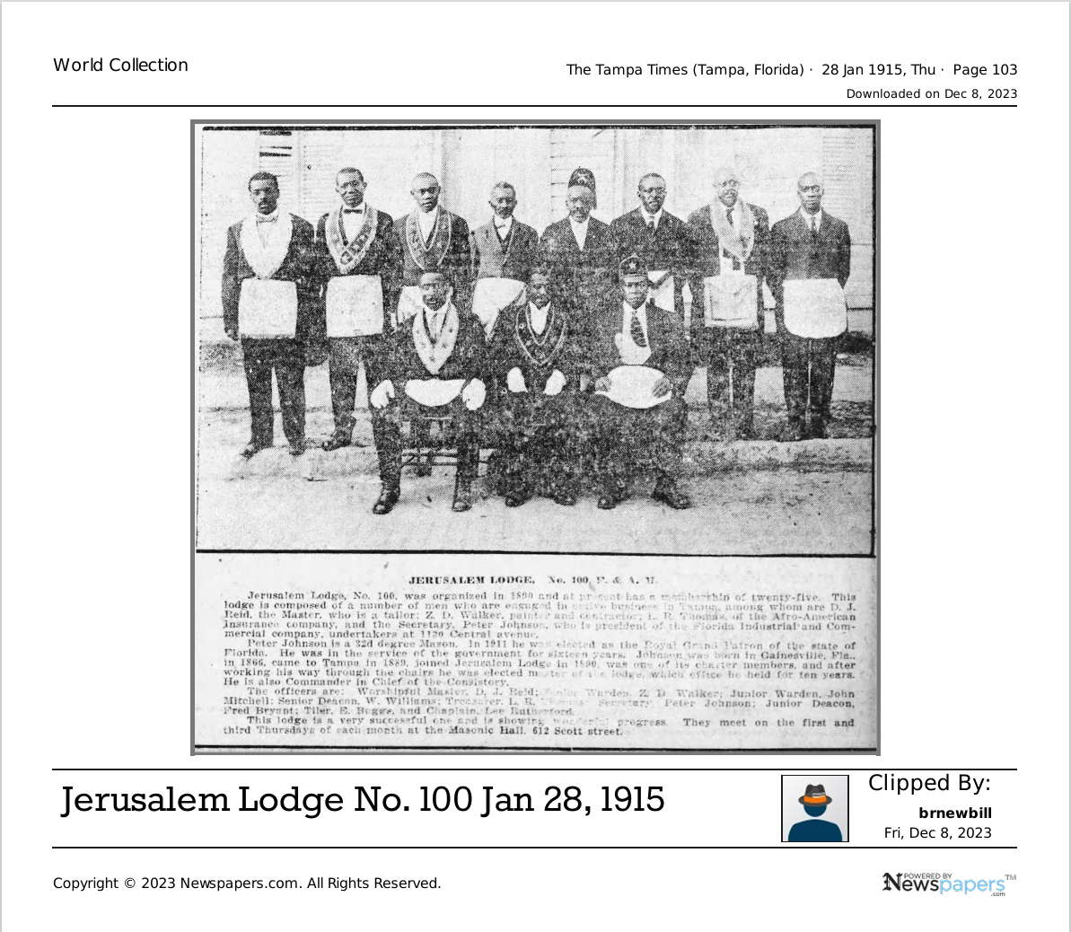
Jerusalem Lodge No. 100, F. & A. M.
As published in The Tampa Times, January 28, 1915 (Transcribed from caption above.)
Jerusalem Lodge, No. 100, was organized in 1910 and at present has a membership of twenty‑five. This lodge is composed of a number of men who are engaged in active business in Tampa, among whom are D. J. Reid, the Master, who is a tailor; Z. D. Walker, painter and contractor; L. R. Thomas, of the Afro‑American Insurance Company; and the Secretary, Peter Johnson, who is president of the Florida Industrial and Commercial Company, undertakers at 1120 Central Avenue.
Peter Johnson is a 32d degree Mason. In 1911 he was elected as the Royal Grand Patron of the state of Florida. He was in the service of the government for sixteen years. Johnson was born in Gainesville, Fla., in 1866, came to Tampa in 1889, joined Jerusalem Lodge in 1890, was one of its charter members, and after working his way through the chairs he was elected master of the lodge, which he held for ten years. He is also Commander in Chief of the Consistory.
The officers are: Worshipful Master, D. J. Reid; Senior Warden, Z. D. Walker; Junior Warden, John Mitchell; Senior Deacon, W. Williams; Treasurer, L. R. Thomas; Secretary, Peter Johnson; Junior Deacon, Fred Bryant; Tiler, E. Buggs; and Chaplain, Lee Rutherford.
This lodge is a very successful one and is showing wonderful progress. They meet on the first and third Thursdays of each month at the Masonic Hall, 612 Scott street.
The following is AI- generated annotations and context.
Biographical Sketches of Lodge Officers (1915)
Worshipful Master — D. J. Reid
A tailor by profession, Reid represented the skilled artisan class that formed the backbone of Tampa’s early Black business district. As Worshipful Master, he presided over lodge operations, ritual work, and community initiatives. His leadership reflects the lodge’s emphasis on discipline, respectability, and professional advancement.
Senior Warden — Z. D. Walker
A painter and contractor, Walker was part of the construction and trades sector that helped build Black Tampa physically and economically. His role as Senior Warden placed him second in command, responsible for overseeing the lodge’s work and assisting the Master.
Junior Warden — John Mitchell
Mitchell held responsibility for the lodge’s moral oversight and the well‑being of its members. His position also placed him in the line of succession for future leadership.
Senior Deacon — W. Williams
Williams assisted in ritual duties and served as a key ceremonial officer. Deacons often acted as liaisons between the Worshipful Master and the membership.
Treasurer — L. R. Thomas
Affiliated with the Afro‑American Insurance Company, Thomas represented the growing Black financial sector. His role as Treasurer placed him in charge of the lodge’s funds, dues, and financial reporting.
Secretary — Peter Johnson
One of the most accomplished Black businessmen in Tampa’s early 20th‑century history.
• 32nd‑degree Scottish Rite Mason
• Royal Grand Patron of Florida (O.E.S.)
• President of the Florida Industrial and Commercial Company
• Undertaker at 1120 Central Avenue
• Former government employee for sixteen years
• Charter member and ten‑year Master of the lodge
• Commander in Chief of the Consistory
Johnson’s influence extended far beyond the lodge, shaping Black enterprise, insurance, and civic life.
Junior Deacon — Fred Bryant
Bryant assisted the Senior Deacon and supported ritual work. Junior Deacons often mentored new members and maintained order during meetings.
Tiler — E. Buggs
As Tiler, Buggs guarded the lodge door and ensured that only qualified Masons entered. This was a position of trust and vigilance.
Chaplain — Lee Rutherford
Rutherford provided spiritual guidance and conducted prayers during meetings. Chaplains were central to the moral and ethical tone of the lodge.

Jerusalem Lodge No. 100 (PHA)
Roster of Known Members, 1910–1930
This roster is divided into three categories to reflect historical certainty:
1. Confirmed Members (Named in 1915 Newspaper Record)
2. Likely Continuing Members (Held major offices; historically remain active for years)
3. Probable Members (Appear in related business, fraternal, or community records)
This structure mirrors how historians reconstruct lodge membership when formal rolls are unavailable.
1. Confirmed Members (1910–1915)
These men are explicitly named in the Tampa Times article of January 28, 1915. They are the core documented membership of the lodge.
Principal Officers and Members
• D. J. Reid — Worshipful Master; tailor
• Z. D. Walker — Senior Warden; painter and contractor
• John Mitchell — Junior Warden
• W. Williams — Senior Deacon
• L. R. Thomas — Treasurer; Afro‑American Insurance Company
• Peter Johnson — Secretary; 32° Mason; undertaker; businessman
• Fred Bryant — Junior Deacon
• E. Buggs — Tiler
• Lee Rutherford — Chaplain
Additional Confirmed Members (Named in First Section)
• L. R. Thomas — also listed as Treasurer
• Z. D. Walker — also listed as Senior Warden
These names appear twice because the article lists occupations separately from the officer roster.
2. Likely Continuing Members (1915–1930)
These men held major offices or had long-standing business roles, making it historically likely they remained active in the lodge for many years.
Long‑Term Leadership Figures
Peter Johnson
• Charter member (joined 1890)
• Master for ten years
• Secretary in 1915
• Commander in Chief of the Consistory
• His prominence suggests continuous involvement through the 1920s.
D. J. Reid
• Worshipful Master in 1915
• Tailors often held stable, long-term roles in fraternal orders.
Z. D. Walker
• Senior Warden in 1915
• Painters/contractors frequently served in lodge leadership for extended periods.
L. R. Thomas
• Treasurer in 1915
• Insurance professionals often remained in lodge finance roles for decades.
Likely Continuing Members Based on Office
• John Mitchell — Junior Warden
• W. Williams — Senior Deacon
• Fred Bryant — Junior Deacon
• E. Buggs — Tiler
• Lee Rutherford — Chaplain
These positions typically indicate multi‑year involvement.
3. Probable Members (1910–1930)
These individuals are not explicitly listed as officers but appear in the lodge’s occupational description or in related community roles.
Probable Members Identified Through Occupation or Association
• Z. D. Walker — appears in both occupational and officer lists
• L. R. Thomas — appears in both lists
• Other unnamed members of the Florida Industrial and Commercial Company (undertakers at 1120 Central Avenue)
• Associates of the Afro‑American Insurance Company
• Associates of the Central Avenue business district
Because fraternal membership was a key part of Black professional identity in early 20th‑century Tampa, it is historically likely that business partners and associates of the confirmed members were also lodge members.

